Professional Development Session 5: Engineering Education and Scientific Method Versus Engineering Design Process

Speaker: Mr. Eugene Rutz, Academic Director, College of Engineering and Applied Science, University of Cincinnati
Date: July 10, 2018
Time: 11:00 am-12:00 noon
Venue: University of Cincinnati, Swift Room 608

Prepared by:
Beth Francis, Felicity Franklin Schools, Felicity Ohio
RET Participants for Project #3 “Bio inspired Optimization of the Multiple Traveling Salesman Problem”

This session was given by Mr. Eugene Rutz. He serves as an Academic Director in the College of Engineering and Applied Science at the University of Cincinnati. Mr. Rutz has oversight of the combined Bachelor/Master's program, the Master of Engineering Program and the collaborative program with regional high school teachers.

Mr. Rutz opened his session by giving some background information about himself and then shared the session agenda. The session started with all of the participants introducing themselves, as seen in Figure 1.

.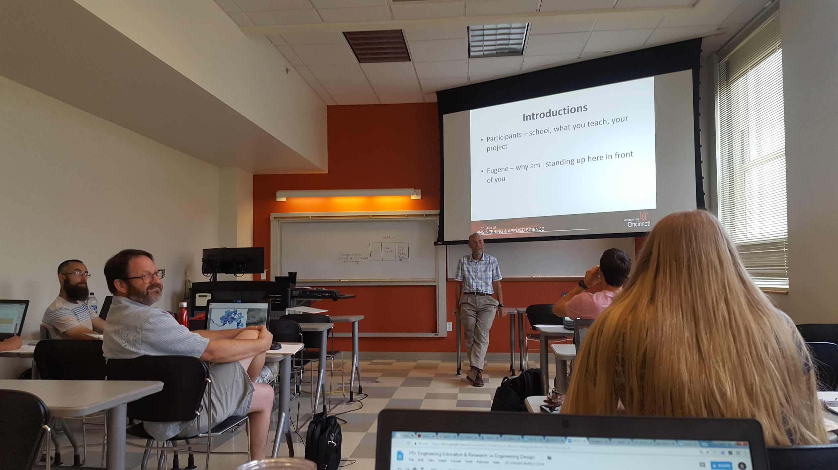
Figure 1: Participants Introduce Themselves to Mr. Rutz

The first topic discussed was around the concept of STEM and assessing what it means. As shown in Figure 2, participants provided their definitions of STEM which led to a discussion about the variation of definitions and why there was so much variance. This discussion led Mr. Rutz to then ask: ”What is engineering?” To lead this discussion, he put up a course list from the Biomedical Engineering program. This list only included a few engineering courses with most of them being applied mathematics and science. He concluded that engineering is a field centered around applied mathematics and science.

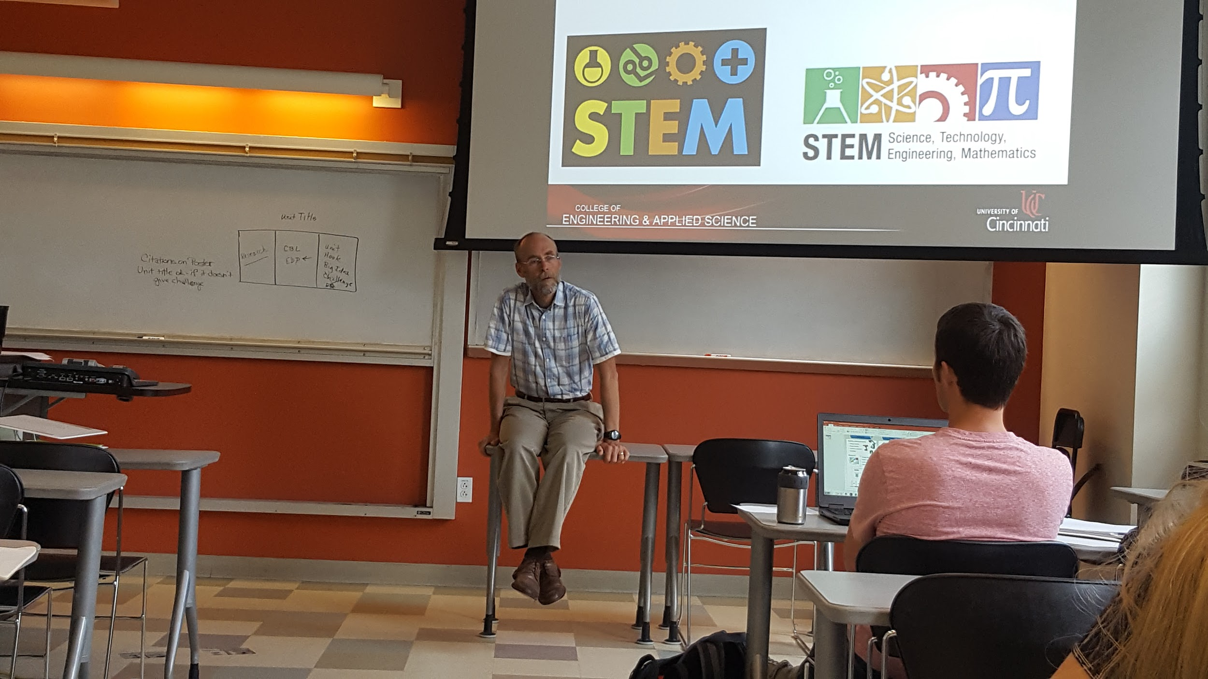
Figure 2: Mr. Rutz Leads a Discussion on the Idea of STEM

The next topic of discussion was about choosing Engineering as a career. Mr. Rutz offered that the most important reason to select Engineering as a career should be because you want to help people and not necessarily because you like mathematics and science. The projected growth for the field of Engineering is 4% from 2014-2024. Figure 3, demonstrates the rate of growth between countries that have trained new engineers between1983-2006. This led to a discussion about the STEM labor market and the job shortages and surpluses in the public and private sectors.

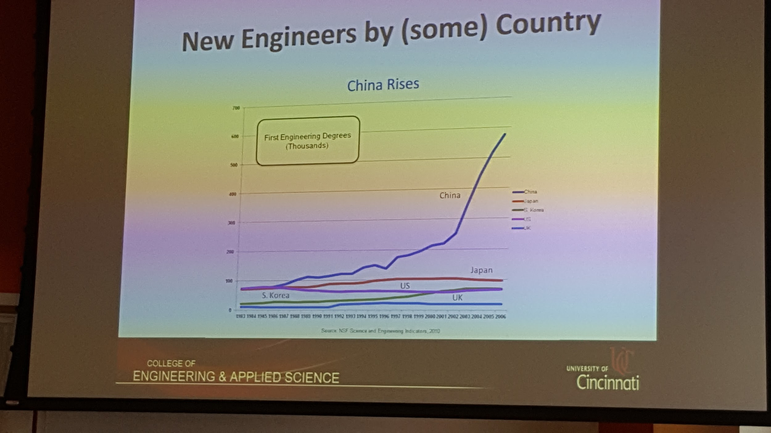
Figure 3: Engineer Training Comparison Chart

Mr. Rutz then discussed the difference between Engineering Technology and Engineering. The discussion started with a list of the courses one should take in high school and the scores necessary on the ACT/SAT for both Engineering and Engineering Technology. Mr. Rutz explained the difference between engineering and engineering technology and shared how Engineering Technology is an option for those who want to go into Engineering but their math or science skills are mediocre. He noted that obtaining a strong background in Algebra will help master the skills required to successfully complete Calculus and Physics.

The final discussion centered on research versus engineering design. Mr. Rutz began this discussion with definitions of both concepts and participants then discussed how they were related. He shared that science is how nature works, while engineering is how you make the device work. He then compared the Scientific Process to the Engineering Design Process both of which are shown below in Figures 4 and 5. Participants shared their understanding of both concepts and then decided the biggest difference was that in science one does an experiment that leads to one answer and in engineering one does a design project with well-defined constraints that leads to various solutions, one of which may be the best. Determining which process you use, depends on the problem you’re attempting to solve. Mr. Rutz ended the presentation with a reminder to choose the correct experience- science or engineering.

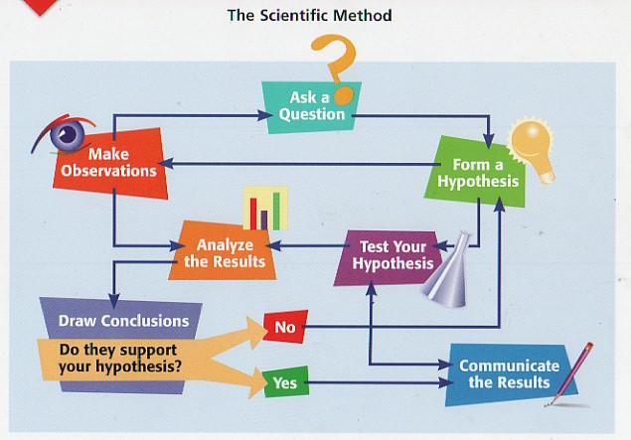  Figure 4: Scientific Method | 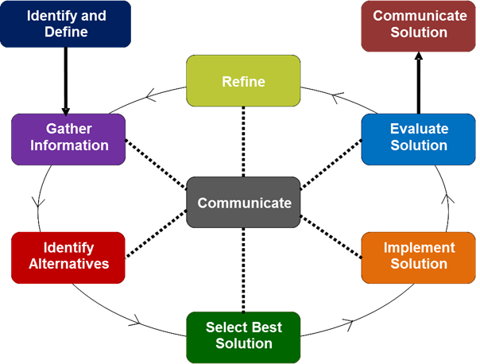  Figure 5: Engineering Design Process

